HIGHER / NATIONAL 5 GEOGRAPHY

FAMILY LEARNING EVENT

National 5 Course Information:
Exam Date – Thursday 6th May | Marks | Duration
Question Paper (Final Exam) | 80 | 2 hour 20 minutes

Higher Course Information:
Exam Date – Thursday 6th May | Marks | Duration
Question Paper 1 – Physical and Human Environments | 100 | 1 hour 50 minutes
Question Paper 2 – Global Issues and Geographical Skills | 60 | 1 hour 10 minutes
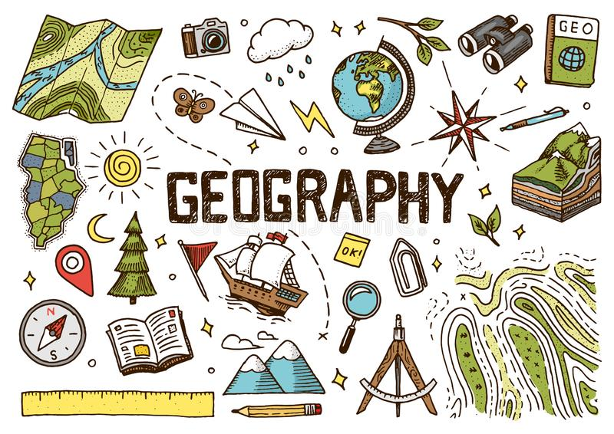

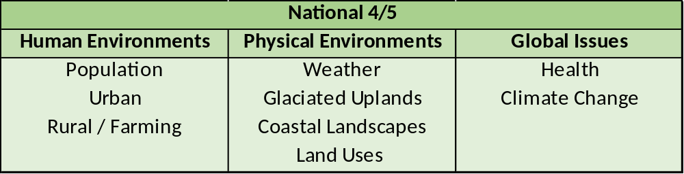
National 5 Course Content
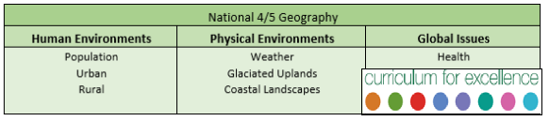

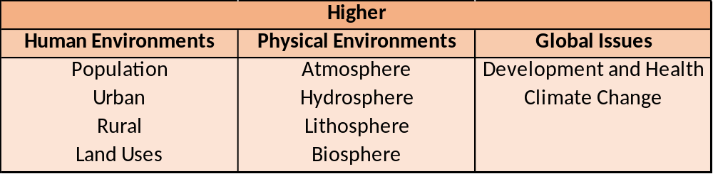
Higher Course Content
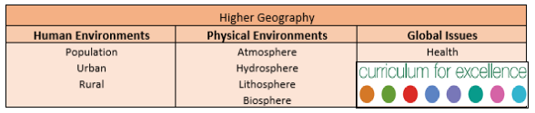

Further Course Information:
Course Specification | https://www.sqa.org.uk/sqa/45768.html
SQA Understanding Standards | https://www.understandingstandards.org.uk/Subjects/Geography
Past Papers | https://www.sqa.org.uk/pastpapers/findpastpaper.htm
Resources:
Lenzie Academy | Class jotters, PPQ booklets, course note booklets, Microsoft Teams, Revision Packs (All Available on Teams)
Textbooks | Hodder & Gibson - How to Pass (Geography N5 / Higher)  Geography – Physical and Human Environments – Ian Geddes
Additional | Chalk Talks – YouTube.com - Online lessons for every N5 / Higher topic

QUESTION PAPER –
Top Tips to success:
- Revise each theory topic thoroughly
- Read the question carefully
- Pay attention to the command word
- Pay attention to the amount of marks allocated
Setting you work space:
- Use a clear line space between each full point
- Use two clear lines between each new question
COMMAND WORDS
COMMAND WORD | WHAT IS IT ASKING? | CONNECTIVES | EXAMPLE
STATE/GIVE/ NAME/ IDENTIFY | Give the name or identifying characteristics of something. | None | One word/short sentence.
DESCRIBE | A THOROUGH description. | This means …  Such as …  For example … | The map shows that HIV rates in South Africa are very high, >10% of adult population are HIV positive.
EXPLAIN | Give the impact or reasons for a particular situation / action.  Give the consequence(s) associated with a particular decision. | This may lead to …  The impact of this would be …  Therefore …  Consequently …  Which means …  This may result in….. | HIV rates in South Africa are high due to a lack of access of proper contraception and due to a lack of sex education.
DISCUSS | A THOROUGH account of the:  ADVANTAGES/DISADVANTAGES  COSTS/BENEFITS  STRENGTHS/WEAKNESSES | On the other hand …  Alternatively …  Otherwise …  Unlike … | One advantage of bed nets as a solution to stopping the spread of malaria is that they protect us when the mosquitos are most active.  On the other hand one disadvantage of bed nets is that it can become expensive to keep retreating them with insecticide.
COMPARE | Discuss similarities and differences between 2 sources of information.  ONE mark PER COMPARISON | Similarities – Both ….  Differences – Whereas …  However….  On the other hand ….

